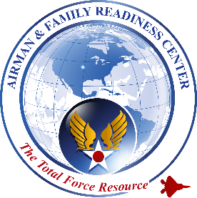
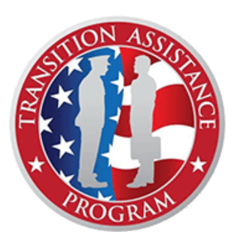
Spangdahlem AB
Transition Assistance Program (TAP)
2024 Schedule

What is TAP?
TAP is a 4-part congressionally mandated program for anyone separating or retiring, regardless of characterization of discharge. Completion of step 1, Initial Counseling and Step 2, Pre-Separation Counseling must occur NLT 365 days prior to the service members anticipated date of separation or retirement.

How to Begin TAP:
Visit www.52fss.com/tap and complete the action items listed under the “Starting TAP” tab. You will then be assigned a TAP Counselor who will guide you through the entire TAP process.

Managing Your (MY) Education
0900-1700
JANUARY | 10-11
MARCH | 20-21
MAY | 22-23
JULY | 24-25
SEPTEMBER | 25-26
NOVEMBER | 6-7
Pre-Separation
Counseling
0900-1200
NOTE: Initial Counseling is a
pre-requisite for this workshop
JANUARY | 4, 18
FEBRUARY | 1, 15, 29
MARCH | 14, 28
APRIL | 11, 25
MAY | 9, 23
JUNE | 6, 27
JULY | 11, 25
AUGUST | 8, 22
SEPTEMBER | 5, 19
OCTOBER | 3, 17, 31
NOVEMBER | 14
DECEMBER | 5, 19
All Pre-sep workshops are hybrid
(in-person & virtual) to accommodate our GSU population.

Transition Assistance Program (TAP) Workshop
0800-1700
NOTE: Pre-Separation Counseling is a pre-requisite for this workshop
**JANUARY | 22-26
FEBRUARY | 5-9
MARCH | 4-8
APRIL | 15-19
*APRIL | 29- May 3
**MAY | 13-17
JUNE | 10-14
JULY | 15-19
**AUGUST | 12-16
SEPTEMBER | 9-13
*SEPTEMBER | 23-27
OCTOBER | 21-25
NOVEMBER | 18-22
**DECEMBER | 9-13
Thur & Fri of TAP week is the Dept of Labor Employment Workshop 2-Day Track
*Senior TAP Class
Participants are E-6 – abv. and O-4 -abv.
**Hybrid workshop (in-person and virtual) to accommodate our GSU population.
Day 2 - VA Benefits Day
will be virtual for all participants.
PRE-SEPARATION TAP WEEK 2-DAY TRACKS
Boots to Business
0900-1700
- JANUARY | 29-30
FEBRUARY | 21-22
- FEBRUARY | 26-27
- MARCH | 25-26
- APRIL | 25-26
MAY | 1-2
- MAY | 20-21
- Virtual Course
• Instructor-led virtual workshops

Dept of Labor
Career & Credential Exploration (C2E)
0900-1700
JANUARY | 29-30
APRIL | 3-4
JULY | 22-23
OCTOBER | 7-8

Thank-you
for your service

